**Displaying ‘Hello World’ On Your Web Browser**



**Hello! And Welcome!** Programming can be useful and fun skill to have, especially for web development. For anyone who is interested in learning to create web pages, displaying ‘Hello World’ on your web browser is an easy and fun way to get started.

For Introduction click here: 

[](https://www.youtube.com/watch?v=2to10tx9tMY)

Need a helping hand? Here is a link to a video that explains each and every step that we will cover here! Just click here: 

[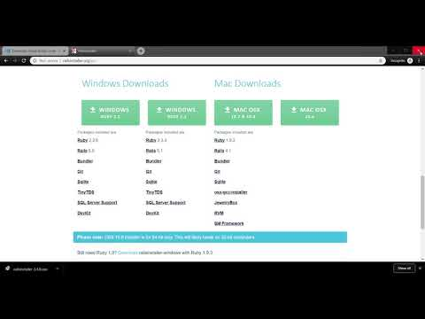](https://www.youtube.com/watch?v=5H03AW-cVzM)

**Things You Will Need**

* A computer
* Visual Studio Code
* *Ruby on Rails* language
* This document

**Wait! Before You Start,**  Make sure you have access to a good Wi-Fi connection to download the required programs and that your laptop or computer is fully charged.

**Here We GO!**

**Step 1** Set up and turn on your computer.



**Step 2** Navigate to Google and type in “visual studio code” and click *Download Visual Studio Code.*

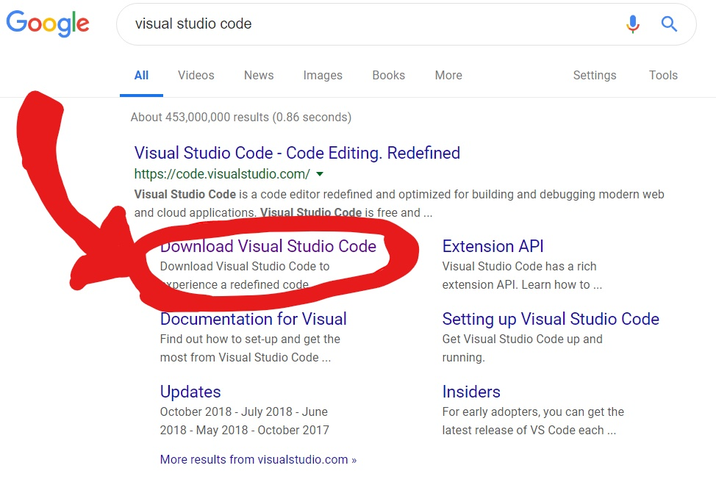

**Step 3** Next, download the version of Visual Studio Code that is right for you. If you have a pc that runs on Windows 7, 8, 10 click on *Windows*. If you have a pc that runs on linux, such as Ubuntu, click on .*deb* or *.rpm*. And if you have a mac, click on *Mac*.

For more details click here: 

[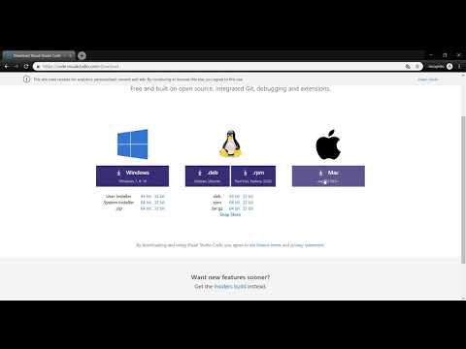](https://www.youtube.com/watch?v=p4WTE3QwcL8)

**Step 4**  Once Visual Studio has downloaded go ahead and start the application. Visual Studio Code will aid you in set up. Go ahead and click agree with all the default settings and agree to the terms and conditions.

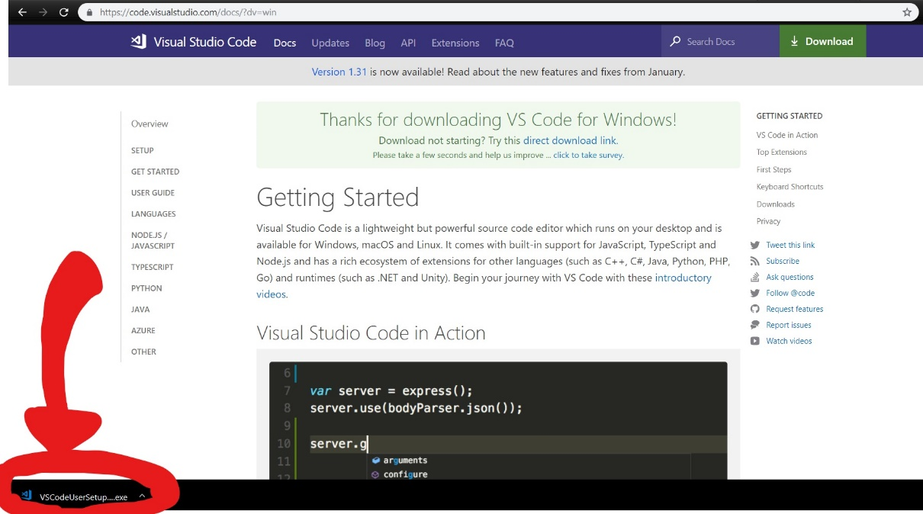

**Step 5** Next, we need to install *Ruby on Rails.* Search “rails installer” on Google and go ahead and click on the first link.

**Step 6** Choose which version of Ruby on Rails to download depending on the operating system on your computer. Be sure to download the latest version.

For more details click here: 

[](https://www.youtube.com/watch?v=5H03AW-cVzM)

**Step 7** Go ahead and run the application and agree to all the default setting and to the terms and conditions.

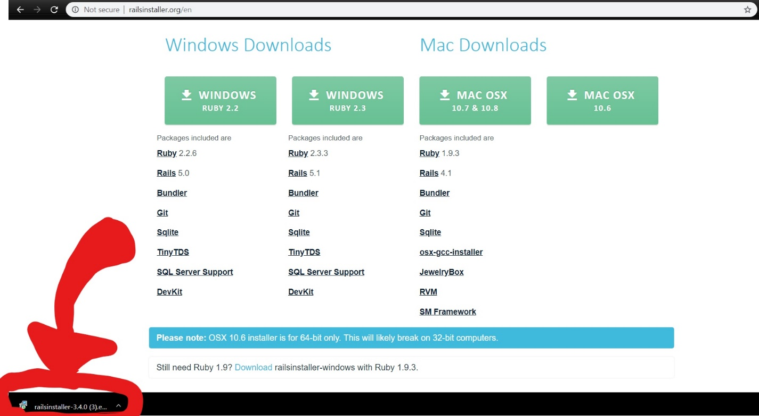

**ALMOST THERE!**

**Step 8** Go ahead and start up Visual Studio Code we had downloaded earlier. You click on the windows icon and type “visual studio code” on the search tap, then click on *Visual Studio Code*.

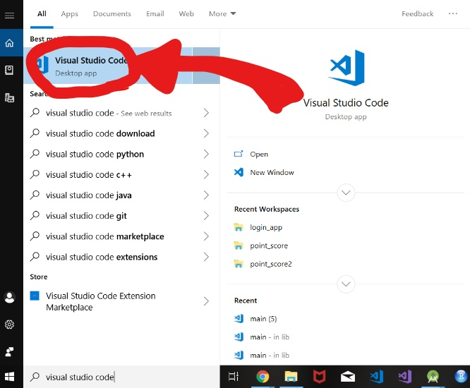

**Step 9** Once Visual Studio Code is open go ahead and make a new file. You can do this by clicking on File at the top left corner and then clicking on New File.

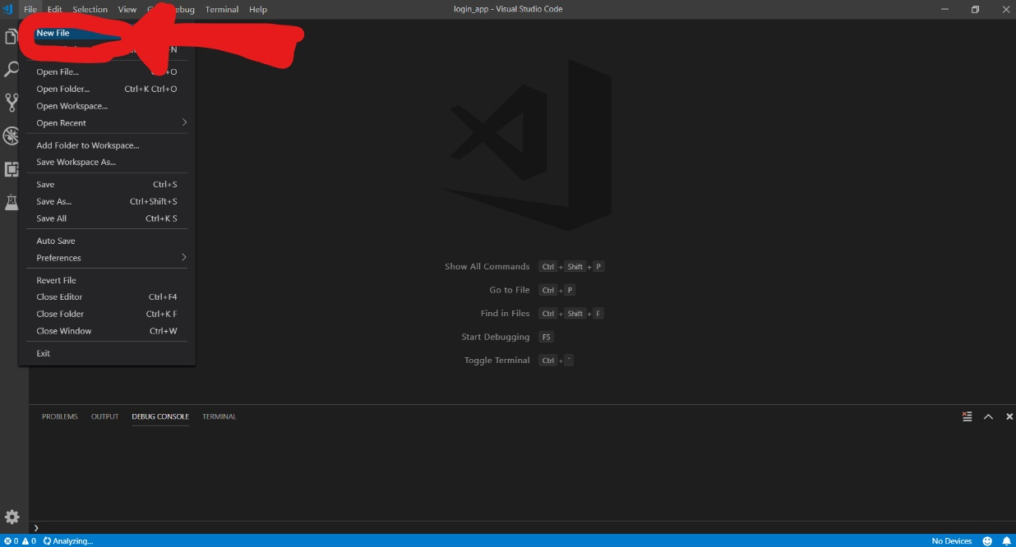

**Step 10** Go ahead and save that file. I saved mine on my Desktop and named it “helloWorld”. Next on the Save as type: tab, scroll down and let’s save our new file as type Ruby to be able to use the language.

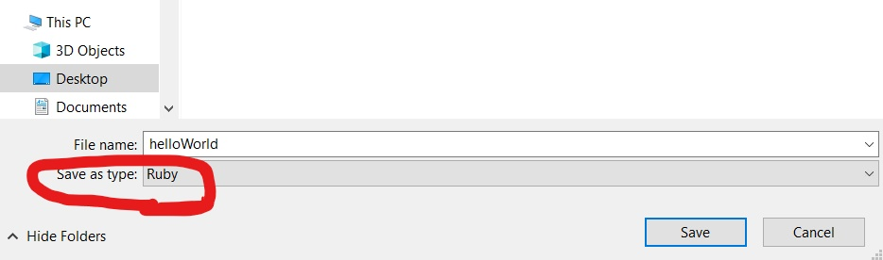

**Step 11** Now we’re going to write our code. Go ahead and type the following code onto Visual Studio Code. “require ‘sinatra’” calls on a special gem in the Ruby language that will allow us to connect to the server once we run our code. The following code is “get ‘/’ do return “Hello World” end”. Is a function that creates a get request to the server and returns a string “Hello World”.

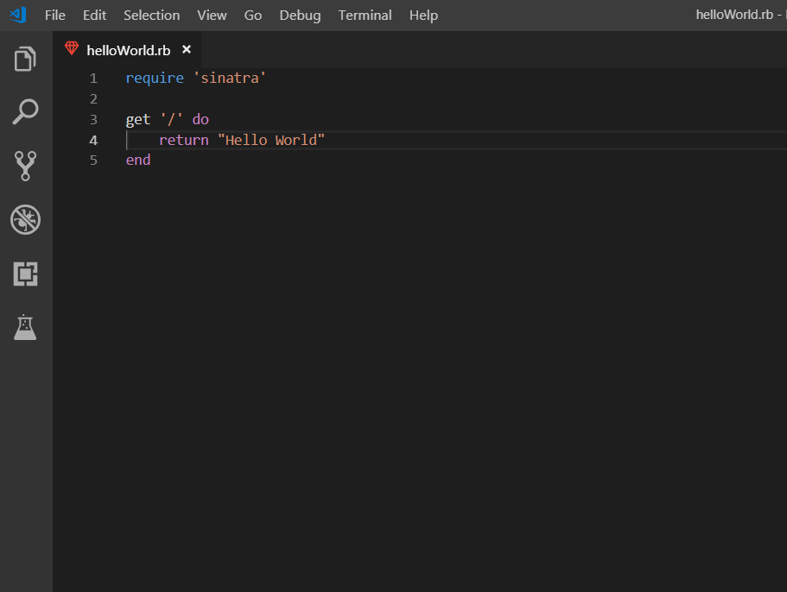

**Step 12** Open your command screen. You can do this by simply typing “cmd” on the search tab after clicking the windows icon. Next type in “cd Desktop” this will take you to your Desktop where we saved our helloWorld file.

**Step 13**  Next type in “gem install sinatra”. Sinatra is a specific add on to Ruby that will allow our program to connect to the server.

**Step 14** And now let’s run our code! Go ahead and type in “ruby helloWorld.rb”.

For more details click here: 

**[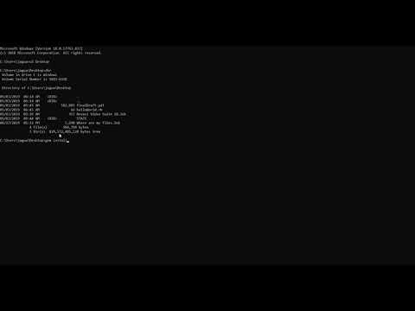](https://www.youtube.com/watch?v=LqtiNEu_Jfk)**

**Step 15**  Go to your internet browser and type “locohost:4567” and watch the fruits of your labor.

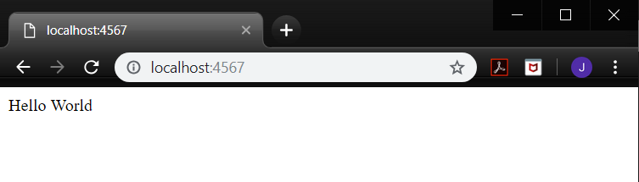

**All Done!**

Congratulations! You have successfully displayed ‘Hello World’ on your web browser and taken your first step towards web development!